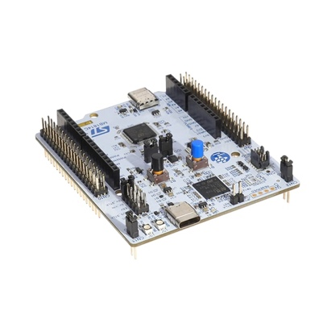 | COMPUTER SCIENCE DEPARTMENT  TE2004B – ADVANCED EMBEDDED SYSTEMS DESIGN  LAB #4 – USART and Bluetooth
 | Name: _________________________  ID: _________________________ | Name: _________________________  ID: _________________________
 | Name: _________________________  ID: _________________________ | Name: _________________________  ID: _________________________

Instructions:

Section 1: Echo test

- Get one USB to TTL Serial cable from the following list:

  - PL2303HX chip (Figure 1). If using Windows then install the driver from the folder where this document is located.

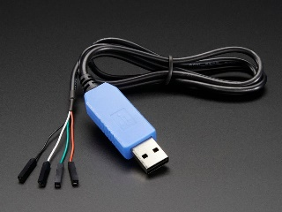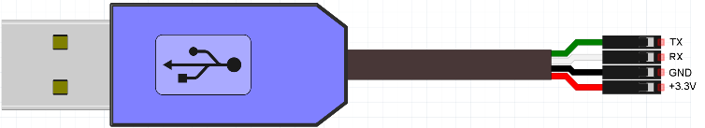
Figure 1.1. PL2303HX USB to TTL Serial cable

  - CP2102 chip (Figure 1). If using Windows then install the driver from here:
https://www.silabs.com/documents/public/software/CP210x_Universal_Windows_Driver.zip

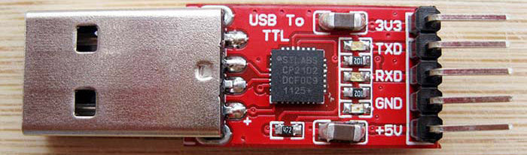
Figure 1.2. CP2102 USB to TTL Serial cable

- Verify in the Device Manager that the selected driver is installed correctly.

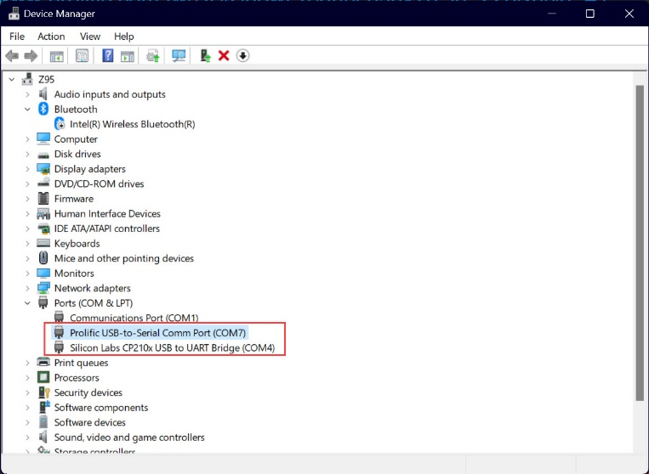
Figure 1.3. Device Manager output
- Connect only the RX pin to the TX pin of the cable.

- Download and uncompress (in any folder of your preference) CoolTerm: https://coolterm.en.lo4d.com/windows.

- Open CoolTerm and click on the Options button. Configure the application as shown in Figure 1.4.

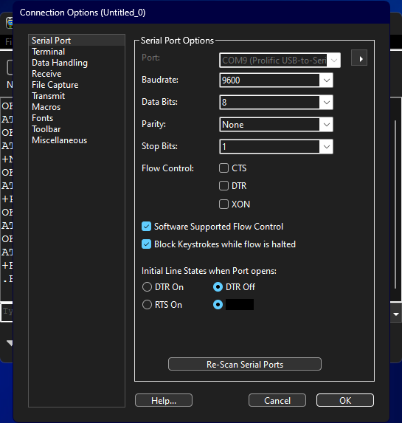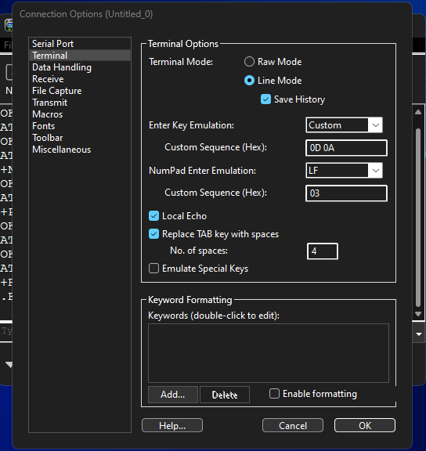
Figure 1.4. Coolterm configuration

- In the left down corner, select the appropriate COM port and then click on connect.

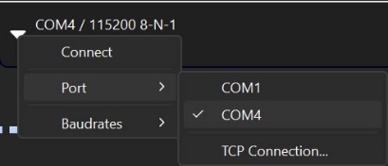
Figure 1.5. COM port selection and connection

- In the terminal program (CoolTerm) type whatever you want. Place a screenshot of the terminal output.

Picture 1.1. Screenshot for the echo test.

- Save current configuration as default by selecting File > Save as Default

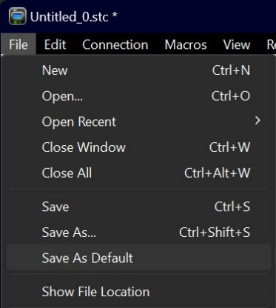
Figure 1.6. Saving current configuration

Section 2: HM10 Bluetooth configuration

- Connect the serial adapter to the HM10 Bluetooth module as in Table 2.1.

Table 2.1. Serial adapter and RN42 connection
Serial adapter | HM10
TXD | RXD
RXD | TXD
GND | GND
3V3 | VCC

- Open CoolTerm. Manually and slowly, introduce the following commands (clicking on the <ENTER> key at the end of each one):

Table 2.2. RN42 configuration
Command | Comments
AT+DEFAULT | Restore factory default
AT+RESET | Software reboot
AT+NAMEBT0 | Set local device name
AT+PINqwerty | Get/Set pin code for pairing
AT+RESET | Software reboot
AT+ROLE0 | Set current role as slave/peripheral

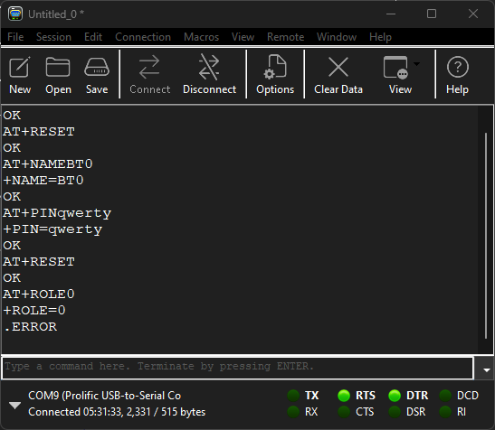
Figure 2.1. Configuration output
Section 3: HM10 Bluetooth configuration

- Install on the smartphone the Serial Bluetooth Terminal application.

- Turn on the Bluetooth function in the smartphone. Pair it with the HM10 module (that has the name configured in the previous section).

- Open the Serial Bluetooth Terminal. Go to three bars button > Devices. Select the device paired in the last step.

- Enter “Input from CoolTerm” (without the quotes) in the CoolTerm terminal. Then enter “Input from smartphone” in the Serial Bluetooth Terminal. Place a screenshot of the output from both programs.

Picture 3.1. Screenshot from CoolTerm output

Picture 3.2. Screenshot from Serial Bluetooth Terminal output

Section 4: Example with USART2 on STM32F3DISCOVERY

- Import the L4 STM32 project into the STM32CubeIDE.

- Using the CoolTerm program, run the project. Table 4.1. describes the behavior of the project. The sequence of bits after the L or S characters is a mask.

Table 4.1. HM10 configuration
Command | Result on the STM32F3DISCOVERY board
L0001 | Turns on PE8 (LD4 LED)
L0000 | Turns off PE8 (LD4 LED)
S0001 | Returns the status of the PA0 pin (user button)

- Place a screenshot of the output in the CoolTerm program from running the project.

Picture 4.1. Screenshot from CoolTerm terminal output running the L3 project

Section 5: USART2 on STM32F3DISCOVERY with HM10 Bluetooth Module

- Connect the HM10 Bluetooth module and send the commands from Table 4.1 from the smartphone.

- Extend the previously used commands to write into 4 LEDs and read from 4 switches.

- Using the Serial Bluetooth Terminal program, run the new project and place a screenshot of the working program.

Picture 5.1. Screenshot from Serial Bluetooth Terminal output running the modified L4 project

- Add and comment the sections of the program modified to implement this new project.

Listing 5.1. Code for section 5

- Explain how does your program works.

Listing 5.2. Description for program in section 5

- Take a picture of the physical circuit.

Picture 5.2. Picture from physical circuit of section 5

